**Project Design Phase-II**

**Data Flow Diagram &User Stories**

|  |  |
| --- | --- |
| Date | 22October 2022 |
| Team ID | PNT2022TMID51722 |
| Project Name | Project – Smart Solutions for Railways |
| Maximum Marks | 4 Marks |

**Data Flow Diagrams:**

A Data Flow Diagram (DFD) is a traditional visual representation of the information flows within a system. A neat and clear DFD can depict the right amount of the system requirement graphically. It shows how data enters and leaves the system, what changes the information, and where data is stored.

**Zero level DFD :**

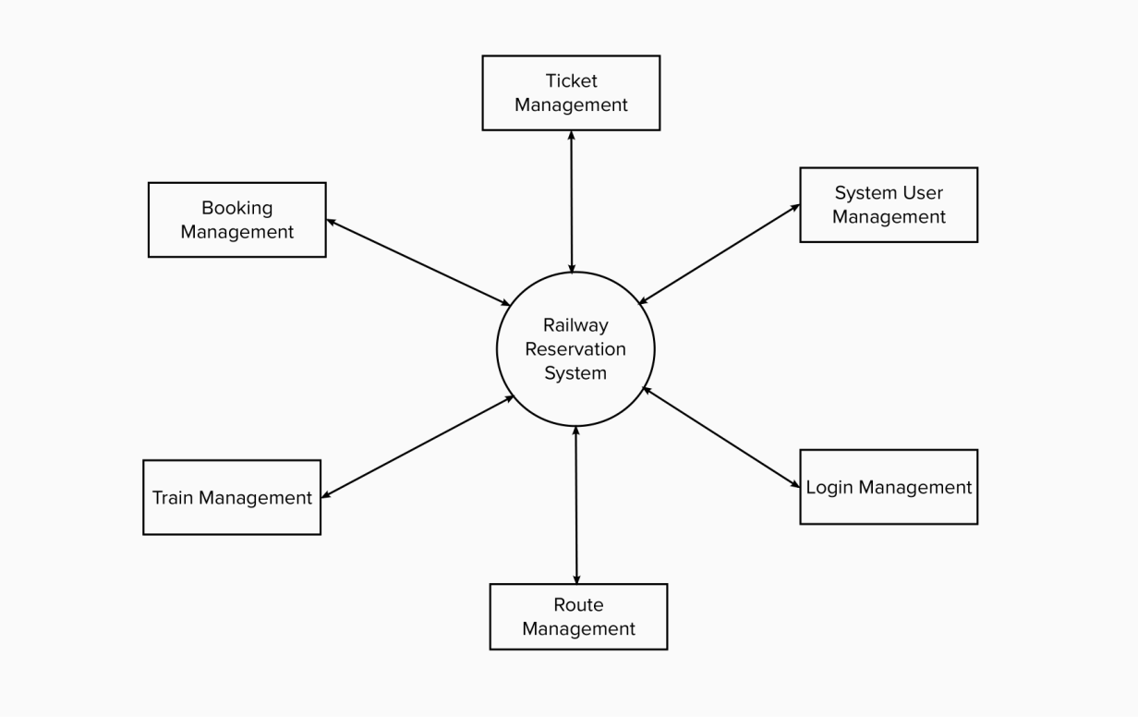

Working process:

* Managing all the trains
* Managing all the booking
* Managing all the ticket
* Managing all the train schedule
* Managing all the train route
* Managing all the customer
* Managing all the payment

**First level DFD:**

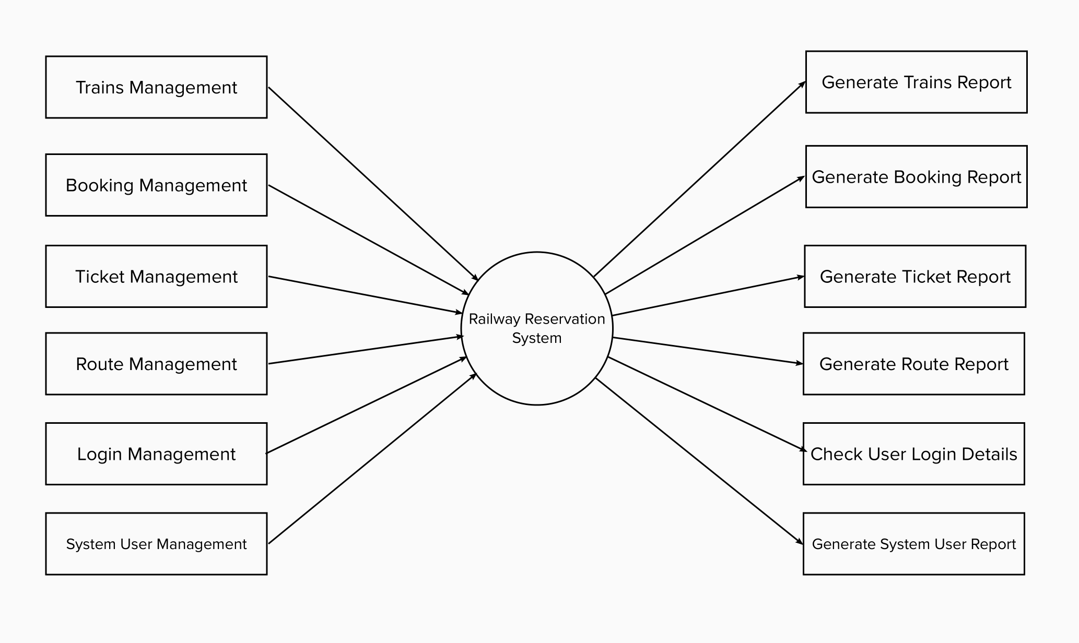

* Processing trains records and generate report of all trains
* Processing booking records and generate report of all booking
* Processing ticket records and generate report of all ticket
* Processing train schedule records and generate report of all train schedule
* Processing train route records and generate report of all train route
* Processing customer records and generate report of all customer
* Processing payment records and generate report of all payment

**Second level DFD:**

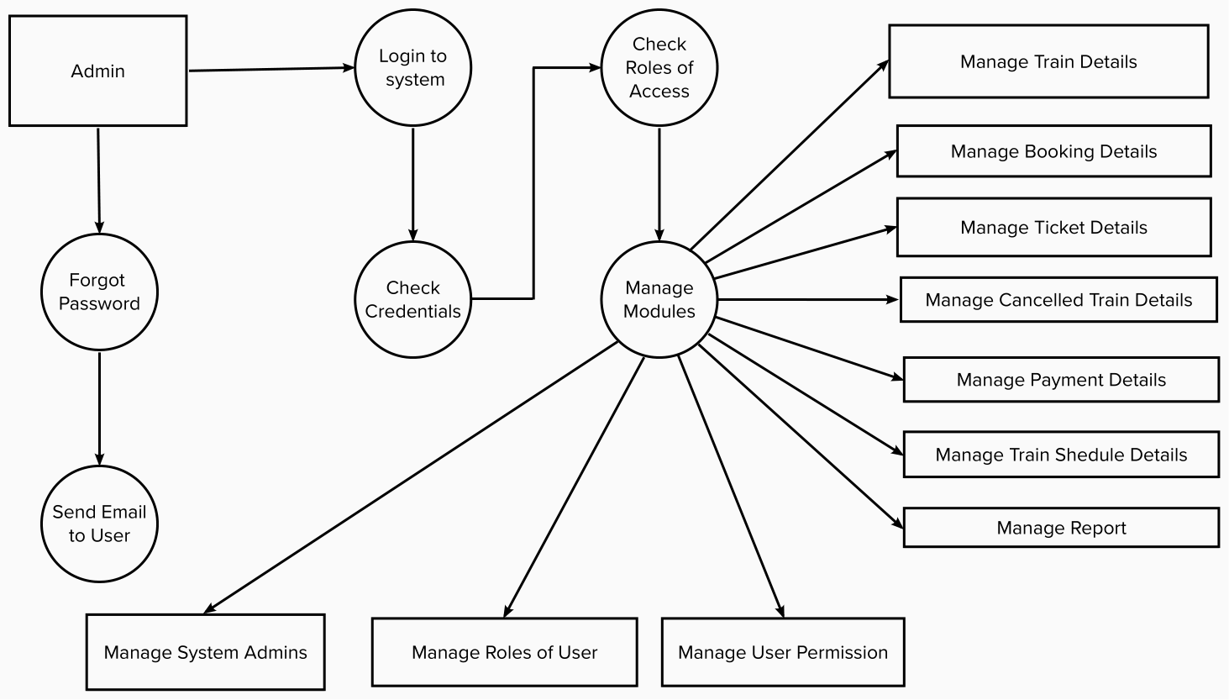

* Admin logins to the system and manage all the functionalities of railway reservation system.
* Admin can add, edit, delete and view the records of trains, ticket, train route, payment.
* Admin can manage all the details of booking, train schedule, customer.
* Admin can also generate reports of trains, booking, ticket, train schedule, train route, customer.
* Admin can search the details of booking, train route, customer.
* Admin can apply different level of filters on report of trains, train schedule, train route.
* Admin can tracks the detailed information of booking, ticket, train schedule, train route.

**User Stories:**

| **User Type** | **Functional Requirement (Epic)** | **User Story Number** | **User Story / Task** | **Acceptance criteria** | **Priority** | **Release** |
| --- | --- | --- | --- | --- | --- | --- |
| Customer (Mobile user) | Registration | USN-1 | As a user, I can register for the application by entering my email, password, and confirming my password. | I can access my account / dashboard | High | Sprint-1 |
| Customer (Mobile user) | Registration | USN-2 | As a user, I will receive confirmation email once I have registered for the application | I can receive confirmation email & click confirm | High | Sprint-1 |
| Customer (Mobile user) | Registration | USN-3 | As a user, I can register for the application through Gmail | I can receive regular updates if wanted and save time to registration and get a QR code for reservation tickets | Medium | Sprint-1 |
| Customer (Mobile user) | Login | USN-4 | As a user, I can log into the application by entering email & password | I can access my profile and dashboard | High | Sprint-1 |
| Customer (Mobile user) | Registration | USN-5 | As a user I can search available train by entering a location and can choose train to book tickets | I can access trains available seat or berth reservation | High | Sprint-2 |
| Customer (Mobile user) | Dashboard | USN-6 | As a user I can see my dashboard once logged into application | I can see recent activities which I have done and access the generated QR code for reserved tickets | High | Sprint-2 |
| Customer (Web user) | Tracking | USN-7 | As a passenger, I can know where the train is by using the application. | I can instantly know when will reach the destination through GPS tracking | Medium | Sprint-3 |
| Customer Care Executive | Help Users to solve issues | USN-8 | As a customer care executive, I have to take action for the customer complaints, request and query. | I can navigate the customers to find where the issue is | Medium | Sprint-4 |
| Administrator | Management | USN-9 | As a Administrator I can manage the cloud and database. | I can report the problem to customer directly through server. | High | Sprint-3 |